
InTouch Online Portal
Setup an InTouch Account
- Click on the InTouch Link, https://az-kyrene.intouchreceipting.com/
- Proceed to the 1st Time Users (Non-Parent) and create a guest account. Hit the create account button
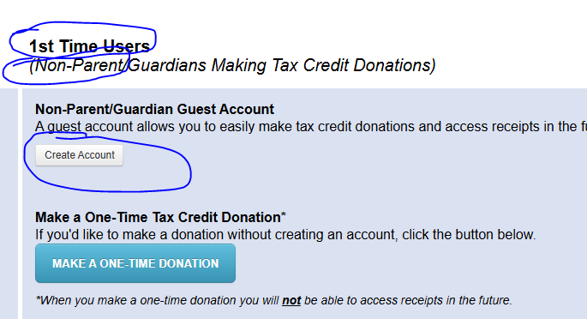
Log In
- Once your account has been setup then you will log in at “Returning Users” with your user name and password.
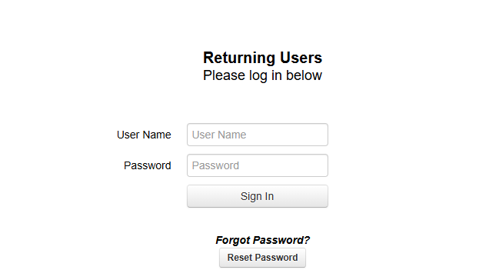

- Click on Items At All Schools
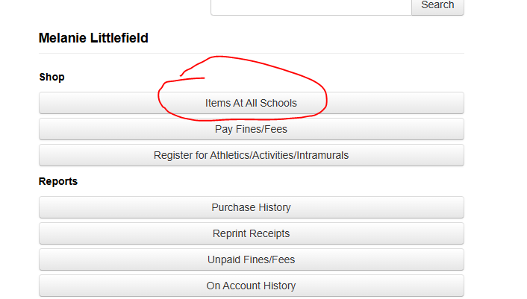
- Click on the District Office Tab
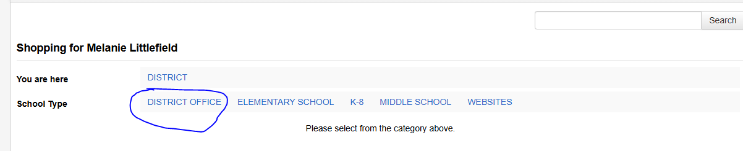
- Click on Kyrene District Business Office

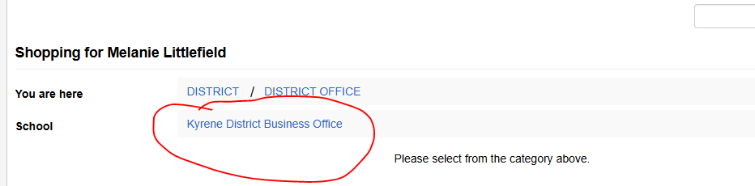

- Click on Print Shop
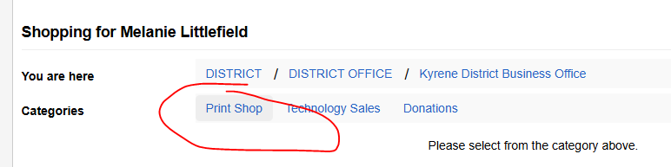

- Input the Total Amount of Invoice/Invoices and Click the blue Buy button
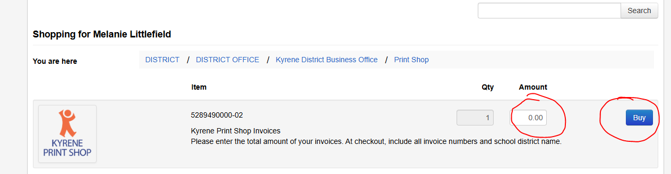

- Then click on the Checkout button
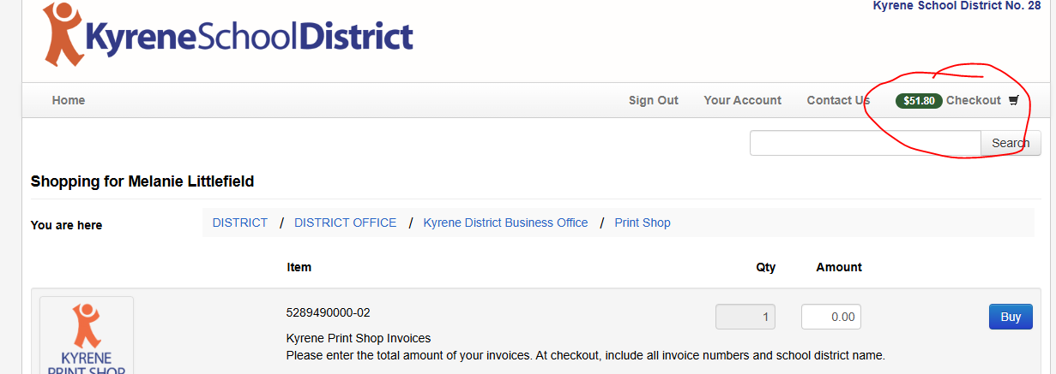

- Click on the Checkout Step 1: Additional Info
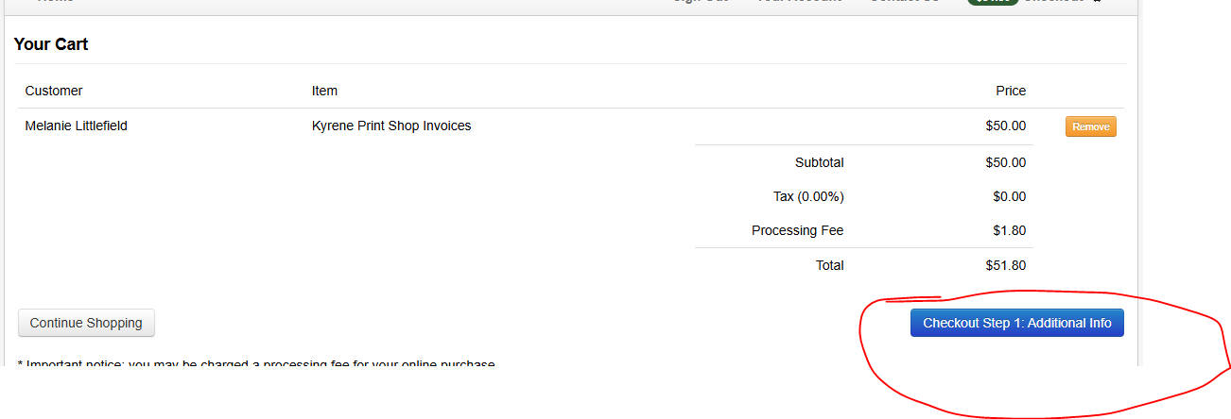

- Add School District Name, Invoice Number(s) and any additional notes. Proceed to the Checkout Step 2 Payment button

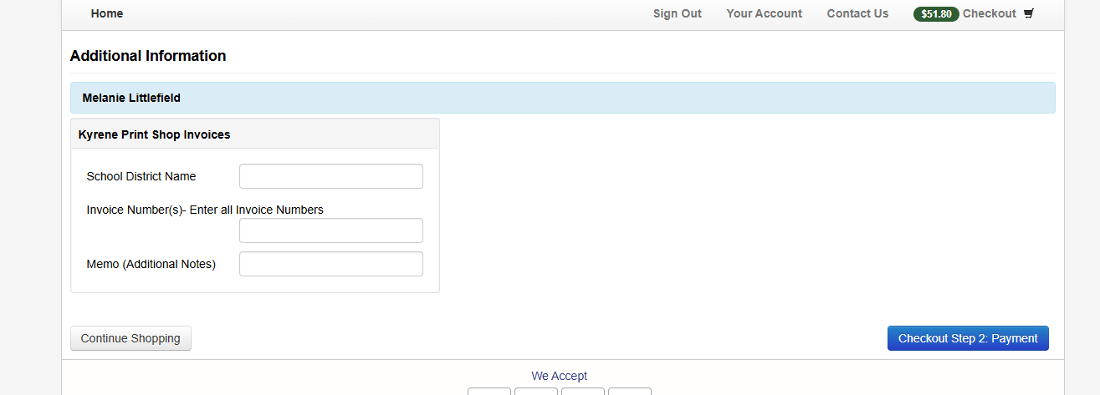

- Enter Credit Card Information and hit the Pay button

